Regulatory Committee
Meeting to be held on 1st July 2015

Electoral Division affected:
Rossendale North

Wildlife and Countryside Act 1981
Definitive Map Modification Order Investigation
Addition of Footpath at Love Clough Fold from Public Footpath No. 1 to Public Footpath No. 9 Rawtenstall, Rossendale Borough
File No. 804-518
(Annex ‘A’ refers)
(Appendices A, B and C refer)

Contact for further information:
Megan Brindle, Legal and Democratic Services, 01772 535604
Megan.brindle@lancashire.gov.uk
Jayne Elliott, Public Rights of Way, Planning and Environment, 07917 836626
Jayne.elliott@lancashire.gov.uk

Executive Summary

Investigation into the addition of a public footpath between Public Footpaths No. 1 and No. 9 Rawtenstall at Love Clough in accordance with file no. 804-518 and the consideration of an Order to add to the Definitive Map and Statement a public footpath.

Recommendation

1. That an Order be made pursuant to Section 53 (2)(b) and Section 53 (3)(c)(i) of the Wildlife and Countryside Act 1981 to record a Public Footpath on the Definitive Map and Statement of Public Rights of Way as shown on Committee Plan between points A-B-C-D.

2. That being satisfied that the higher test for confirmation can be met the Order be promoted to confirmation.

3. That the 2006 Order made following the Committee Decision of 27 September 2006 concerning application 804-421 be submitted to the Secretary of State requesting non-confirmation.

Background

In 2005 an application was received for a footpath starting at point A on the Committee plan but following a different alignment to the route that is the subject of this report.

The 2005 application was accepted by Committee at their meeting on 27 September 2006 and a Definitive Map Modification Order was made. Copies of the Committee report and Legal Order are appended to this report.(Appendices A and B refer)

Objections where received to the making of the Order and following further investigation it was discovered that the Order route had only come into existence on that alignment following the development of farm buildings into residential properties in the late 1980s. However, the map and documentary evidence, and evidence of use submitted with the application appeared to relate more closely to the layout of the buildings when they were part of a working farm, before redevelopment took place. It was therefore decided to investigate the matter again to determine, using all the evidence, exactly where a public right of way might lie.

Interviews were carried out with a number of the users that had filled in forms that were submitted with the original application and all users were sent a photocopy of a photograph of the site prior to development with a request that they mark on the route that they claimed to have used.

As a result of those interviews it is the view of Officers that there is insufficient evidence to promote the 2005 Order through to confirmation and an investigation has now been carried out into the route shown on the Committee plan by a bold dashed line and marked between points A-B-C-D.

In addition to the problems of the evidence, Orders are drawn up under Regulations of 1993 which prescribe what notations have to be used on a definitive map but also states that these same notations should be used on order maps. This provision was not followed by many authorities and notations which were technically incorrect had become standard. The Order Map for this 2006 Order shows the public footpath as a solid black line which does not comply with the Regulations.

The Planning Inspectorate had in the past accepted many orders with incorrect notations but stated in a letter to all authorities of 7 September 2011, that they would 'accept any order containing incorrect notation if the order was made prior to 7 September 2011.' The Planning Inspectorate Advice Note 22 was revised on 1st May 2013, attached as appendix A, and this no longer allows Authorities to submit Orders where an incorrect notation is used and states "… an order is considered to be fatally flawed if the wrong notation or non-standard notation (i.e. notation other than that set out in SI 1993 No.12) is used to depict the routes affected by the order. We will therefore reject any order containing incorrect notation."

A full investigation has been carried out of the route marked between points A-B-C-D on the Committee plan and this report details that investigation and the evidence that was brought to light following the interviews carried out by Officers of Legal and Democratic Services.

The County Council is required by law to investigate the evidence and make a decision based on that evidence as to whether a public right of way exists, and if so its status. Section 53(3)(b) and (c) of the Wildlife and Countryside Act 1981 set out the tests that need to be met when reaching a decision; also current Case Law needs to be applied.

An order will only be made to add a public right of way to the Definitive Map and Statement if the evidence shows that:
- A right of way “subsists” or is “reasonably alleged to subsist”

When considering evidence, if it is shown that a highway existed then highway rights continue to exist (“once a highway, always a highway”) even if a route has since become disused or obstructed unless a legal order stopping up or diverting the rights has been made. Section 53 of the Wildlife and Countryside Act 1981 (as explained in Planning Inspectorate’s Advice Note No. 7) makes it clear that considerations such as suitability, the security of properties and the wishes of adjacent landowners cannot be considered. The Planning Inspectorate’s website also gives guidance about the interpretation of evidence.

The County Council’s decision will be based on the interpretation of the evidence discovered by officers and documents and other evidence supplied by the applicant, landowners, consultees and other interested parties produced to the County Council before the date of the decision. Each piece of evidence will be tested and the evidence overall weighed on the balance of probabilities. It is possible that the Council’s decision may be different from the status given in any original application. The decision may be that the routes have public rights as a footpath, bridleway, restricted byway or byway open to all traffic, or that no such right of way exists. The decision may also be that the routes to be added or deleted vary in length or location from those that were originally considered.

Consultations

Rossendale Borough Council has been consulted and no response has been received, it is assumed they have no comments to make.

Applicant/Landowners/Supporters/Objectors

The evidence submitted by the applicant/landowners/supporters/objectors and observations on those comments are included in Advice – Legal and Democratic Service's Observations.

Advice

Public Rights of Way, Planning and Environment Service's Observations

Points annotated on the attached Committee plan.

Point | Grid Reference (SD) | Description
A | 8105 2725 | Junction with Rawtenstall Footpath 1
B | 8108 2727 | Unmarked point at which the route under investigation moves away from the bank of the watercourse.
C | 8110 2730 | Point at which the route under investigation passes the south east corner of the building now known as Clough Fold Barn.
D | 8113 2733 | Junction with Rawtenstall Footpath 9

Description of Route

A site inspection was carried out on 13th November 2014.

The route under investigation commences at a point on Public Footpath no. 1 Rawtenstall on the north side of the bridge over Limy Water and shown as point A on the Committee plan.

From point A the route under investigation extends in a north-easterly direction parallel to Public Footpath 4 Rawtenstall (legally recorded to the south of the route under investigation within the boundaries of the watercourse) following a tarmac access road approximately 3 metres wide, which provides access to the CPA Social and Bowling Club and a number of residential properties. A street light is located on the route close to point A.

The route under investigation passes the front of the Social Club but is separated from the Club by a substantial stone wall. Access to the club is via a pedestrian gate near to point A and vehicular access is also available by travelling along the route under investigation to a small car parking area on the north side of the route which is accessed just before reaching point B.

Between point A and point B the route under investigation is bounded by a stone wall on the south side which forms part of the man-made stone banking that defines the route of the watercourse (Limy Water). On the north side, the route is bounded first by a stone wall and then a wooden fence, both of which mark the boundary of the Social Club. There are no signs, gates or barriers at point A indicating whether the route is considered to be public or private.

Ornate iron gates have been erected across the route at point B. The gates were open when the route was inspected and access through them was freely available. The gates are approximately 5 foot high rising to over 6 foot high where they come together in the centre. If the gates were locked there would be no access over or around them for pedestrians attempting to use the route. A lock existed as an intrinsic part of the gate but it was not possible to determine at the time of the inspection whether it was used. A notice was erected on the gates (which had not been present in 2005 when the original application was made) which stated "Private Road (Resident access only) Please Keep Dogs on Lead & off the Grass Verge".

Beyond point B the land over which the route under investigation passes no longer looks like it did during the time that it is claimed to have been used because the farm buildings have been redeveloped into a number of residential properties.

From point B the route under investigation continues in a generally north-easterly direction but is now obstructed by the garden wall of The Barn. The line of the route passes through the front garden and into the garden of the neighbouring property (Clough Fold Barn) which has been split into two properties and extended on the eastern end. Detailed measurements have not been taken but this extension appears to extend out across the route (at point C).

From point C the route continues through the garden of 2 Clough Fold Barn, passing through the boundary between 2 and 1 Clough Fold Barn (no access) and across the garden area to the east of 1 Clough Fold Barn. Access along the route is further prevented by a boundary wall/hedge.

The route then crosses a private access road that provides access to a number of properties and then passes through a wooden fence (no access) to continue across a garden area in a north-easterly direction and another wooden fence (no access) to reach Public Footpath 9 Rawtenstall at point D.

The total length of the route is 120 metres.

Map and Documentary Evidence

Document Title | Date | Brief Description of Document & Nature of Evidence
Yates’ Map  of Lancashire | 1786 | Small scale commercial map. Such maps were on sale to the public and hence to be of use to their customers the routes shown had to be available for the public to use. However, they were privately produced without a known system of consultation or checking. Limitations of scale also limited the routes that could be shown.
Observations |  | The map shows and names the village of 'Love Clough'. It shows Limy Water and a scattering of buildings but the route under investigation is not shown.
Investigating Officer's Comments |  | The route did not exist as a major route at that time although it may have existed as a minor route which, due to the limitations of scale and the purpose for which the map was drawn meant that it would not have been shown so no inference can be drawn.
Honour of Clitheroe Map | 1804-1810 | A privately produced map of land owned by the Honour of Clitheroe – Henry Duke of Buccleuth and Elizabeth Dutches of Buccleuth. It specifically showing the boundaries of coal leases granted by them. 'Roads' were identified in the key but there was no apparent distinction between those which may have been considered to be public or private.
Observations |  | 'Love Clough' is shown and named on the map but the route under investigation is not shown.
Investigating Officer's Comments |  | The route did not exist as a major route at that time although it may have existed as a minor route which, due to the limitations of scale and the purpose for which the map was drawn meant that it would not have been shown so no inference can be drawn.
Greenwood’s Map of Lancashire | 1818 | Small scale commercial map. In contrast to other map makers of the era Greenwood stated in the legend that this map showed private as well as public roads and the two were not differentiated between within the key panel.
Observations |  | The map shows Commercial Street crossing Limey Water, and continuing to the north west. It shows a number of buildings and names them as 'Low Booth'. The route under investigation is not shown.
Investigating Officer's Comments |  | The route did not exist as a major route in 1818 although it may have existed as a minor route which, due to the limitations of scale and the purpose for which the map was drawn meant that it would not have been shown so no inference can be drawn.
Hennet's Map of Lancashire | 1830 | A further small scale commercial map. In 1830 Henry Teesdale of London published George Hennet's Map of Lancashire surveyed in 1828-1829 at a scale of 7½ inches to 1 mile. Hennet’s finer hachuring was no more successful than Greenwood’s in portraying Lancashire’s hills and valleys but his mapping of the county's communications network was generally considered to be the clearest and most helpful that had yet been achieved.
Observations |  | Love Clough is shown and named but the route under investigation is not shown.
Investigating Officer's Comments |  | The route did not exist as a major route in 1830 although it may have existed as a minor route which, due to the limitations of scale and the purpose for which the map was drawn meant that it would not have been shown so no inference can be drawn.
Canal and Railway Acts |  | Canals and railways were the vital infrastructure for a modernising economy and hence, like motorways and high speed rail links today, legislation enabled these to be built by compulsion where agreement couldn't be reached. It was important to get the details right by making provision for any public rights of way to avoid objections but not to provide expensive crossings unless they really were public rights of way. This information is also often available for proposed canals and railways which were never built.
Observations |  | The route under investigation does not cross land affected by the planned construction of a canal or railway.
Investigating Officer's Comments |  | No inference can be drawn.
Tithe Map and Tithe Award or Apportionment |  | Maps and other documents were produced under the Tithe Commutation Act of 1836 to record land capable of producing a crop and what each landowner should pay in lieu of tithes to the church. The maps are usually detailed large scale maps of a parish and while they were not produced specifically to show roads or public rights of way, the maps do show roads quite accurately and can provide useful supporting evidence (in conjunction with the written tithe award) and additional information from which the status of ways may be inferred.
Observations |  | There is no Tithe Map in the County Records Office for the area under investigation.
Investigating Officer's Comments |  | No inference can be drawn.
Inclosure Act Award and Maps |  | Inclosure Awards are legal documents made under private acts of Parliament or general acts (post 1801) for reforming medieval farming practices, and also enabled new rights of way layouts in a parish to be made. They can provide conclusive evidence of status.
Observations |  | No Inclosure Award was found for the area under investigation.
Investigating Officer's Comments |  | No inference can be drawn.
6 Inch Ordnance Survey (OS) Map sheets 64 and 72 | 1849 | The earliest Ordnance Survey 6 inch map for this area surveyed in 1844-7 and published in 1849.
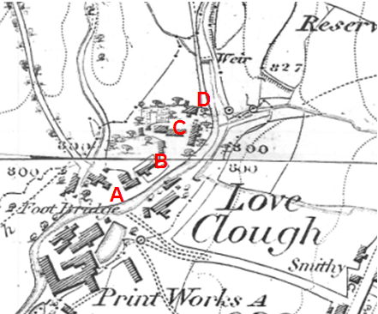
Observations |  | The map shows a number of buildings in close proximity to the route under investigation which are not named. The route is not shown on the map although access onto it appears to be available at point A passing between the watercourse and a building and then continuing along a more restricted but accessible length to the south east of a second building to point B. From point B the route is not shown but it appears that it could have been possible to pass across open ground to point C where the line of the route passes between buildings. Further buildings are shown on either side of the route under investigation between point C and point D – some of which may have been clipped by the route. From point D a track is shown leading north along the western side of Limy Water consistent with the route now recorded as Rawtenstall Footpath 9.
Investigating Officer's Comments |  | The route under investigation did not exist as a defined route on the ground in 1849 although it may have been physically possible to pass along the route – or close to the line of the route - between the properties shown.
25 Inch OS Map | 1893 | The earliest OS map at a scale of 25 inch to the mile. Surveyed in 1891 and published in 1893.
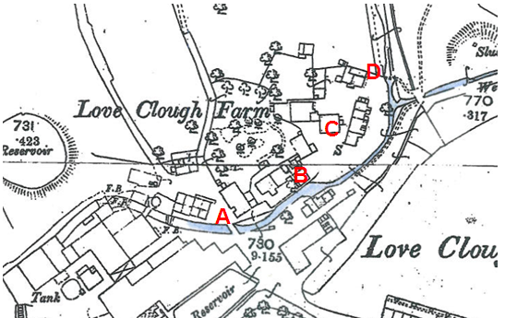
Observations |  | The 25 inch scale map provides more detail than the earlier 6 inch map. The blue colouring on the map extract has been added by the County Council to clarify the location of the watercourse.  The map shows that the route under investigation crossed an open strip of land between the building and the watercourse from point A separated from the properties to the north of the route by a boundary. Partway between point A and point B this strip narrows considerably (to approx. 1 metre) as far as just beyond point B.  From here the route under investigation is not shown as a defined route but crosses an open area of land to point C. Between point C and point D some buildings are shown to the east of the route which the line of the route passes through - although access appears available on either side of the buildings to point D.  At point D a line is shown across what appears to be the boundary of the farm north of which is a track which is consistent with the route now recorded as Rawtenstall Footpath 9. Immediately east of the line is the watercourse and on the east side of the watercourse there is a double pecked line leading from/to it suggesting that a route existed to or across the watercourse at this point.  The buildings between point A and point D collectively appear to form part of Love Clough Farm (named on the map). The area through which the route under investigation appears to be farm with additional buildings which may have been a collection of barns and cottages associated with the farm.
Investigating Officer's Comments |  | The route under investigation did not appear to exist in 1891 although access along most of it may have been available. Between point C and point D buildings extended across the route.  Pedestrian access to these buildings appears to have been via the route under investigation between point A and point B suggesting that the 1m wide section was passable.
25 inch OS Map | 1911 | Further edition of the 25 inch map surveyed in 1892, revised in 1909 and published in 1911.
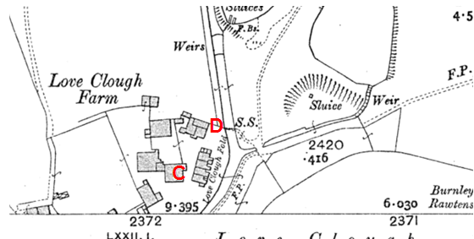
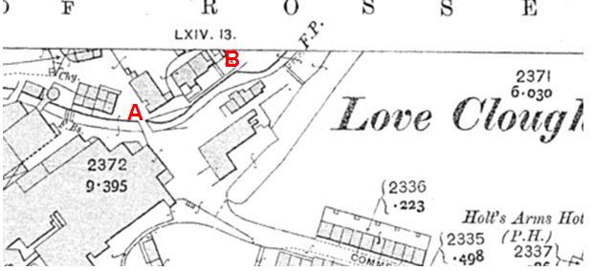
Observations |  | Shows the area similar to the earlier (first) edition of the 25 inch map. An open access way to the farm buildings appeared to exist between point A and point B the width of which was defined by boundaries. The buildings through which the route under investigation passes between point C and point D are labelled as Love Clough Fold. At point D a boundary is shown across the route of what is now Rawtenstall Footpath 9 and immediately east of point D stepping stones are marked on the map providing a crossing of Limy Water.
Investigating Officer's Comments |  | The route under investigation did not appear to exist in 1909. Access along most of it may have been available with some buildings over it near point C and point D.  Pedestrian access to these buildings appears to have been via the route under investigation between point A and point B suggesting that the 1m wide section was passable.
Finance Act 1910 Map | 1910 | The comprehensive survey carried out for the Finance Act 1910, later repealed, was for the purposes of land valuation not recording public rights of way but can often provide very good evidence. Making a false claim for a deduction was an offence although a deduction did not have to be claimed so although there was a financial incentive a public right of way did not have to be admitted.  Maps, valuation books and field books produced under the requirements of the 1910 Finance Act have been examined. The Act required all land in private ownership to be recorded so that it could be valued and the owner taxed on any incremental value if the land was subsequently sold. The maps show land divided into parcels on which tax was levied, and accompanying valuation books provide details of the value of each parcel of land, along with the name of the owner and tenant (where applicable).  An owner of land could claim a reduction in tax if his land was crossed by a public right of way and this can be found in the relevant valuation book. However, the exact route of the right of way was not recorded in the book or on the accompanying map. Where only one path was shown by the Ordnance Survey through the landholding, it is likely that the path shown is the one referred to, but we cannot be certain. In the case where many paths are shown, it is not possible to know which path or paths the valuation book entry refers to. It should also be noted that if no reduction was claimed this does not necessarily mean that no right of way existed.
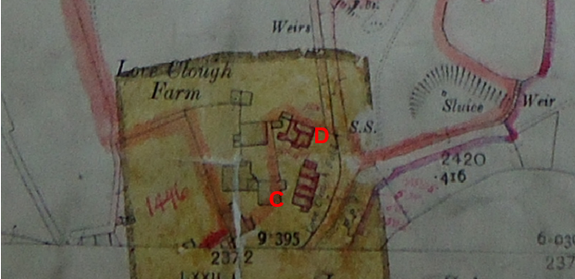
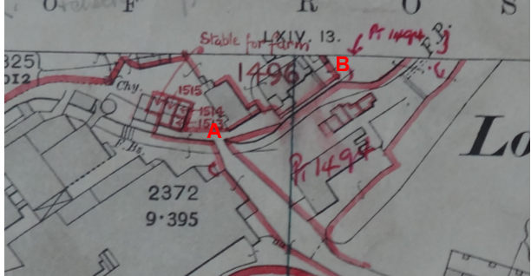
Observations |  | No Finance Act records are available in County Records Office and it has therefore been necessary to request a copy of the Map and relevant Field Book entries from the National Archives.  The route under investigation is not excluded from the numbered hereditaments. The quality of one of the maps held at the National Archives Office is very poor but it appears that the whole length of the route under investigation was included in a single numbered hereditament labelled as part of 1491. It has not been possible to locate a copy of the field book to see whether any deductions where made for the existence of a public right of way.
Investigating Officer's Comments |  | The route under investigation was not excluded from the numbered hereditaments suggesting that it was not considered to be a vehicular public highway at that time. Because it has not been possible to find the relevant field book no inference can be drawn with regards to whether the landowner at that time considered the route to be a public footpath or bridleway. However, as the plot number covered a much larger area than the one crossed by the route under investigation it is unlikely that the field book would have provided strong evidence of the existence (or not) of public rights.
25 Inch OS Map | 1930 | Further edition of 25 inch map (surveyed 1891, revised in 1928 and published 1930)
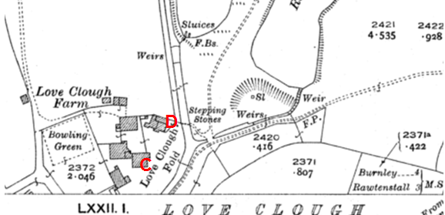
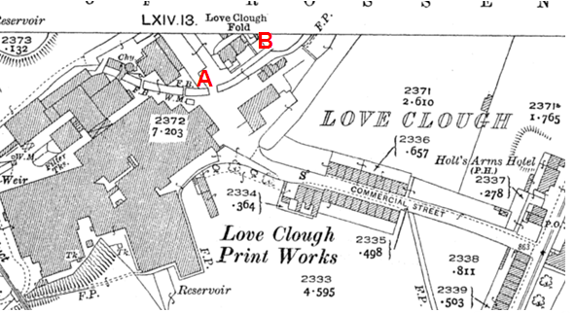
Observations |  | Access to the properties labelled as Love Clough Fold still appears to be via the route under investigation between point A an point B and this is shown to be of a greater width than on earlier editions of the map. The cottages that had been located on the route between point C and point D are not shown and the full route appears to be available.
Investigating Officer's Comments |  | The route under investigation did not appear to exist in 1928. However access along it may have been available to link to the route of Footpath 9 and the stepping stones adjacent to point D.
Aerial Photograph | 1940s | The earliest set of aerial photographs available was taken just after the Second World War in the 1940s and can be viewed on GIS. The clarity is generally very variable.
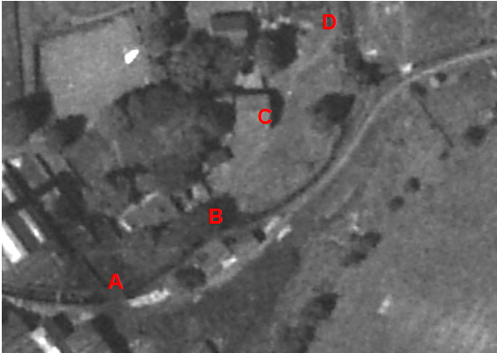
Observations |  | The route between point A and point B cannot be seen due to tree cover. Between point B-C-D a faint route corresponding largely with the route under investigation can be seen.
Investigating Officer's Comments |  | Access along the route between point A and point B cannot be seen but a faint line can be seen extending from point B suggesting that it was available. A faint line can be seen between point B-C-D which is consistent with use of a route on foot.
Authentic Map Directory of South Lancashire by Geographia | Circa 1934 | An independently produced A-Z atlas of Central and South Lancashire published to meet the demand for such a large-scale, detailed street map in the area. The Atlas consisted of a large scale coloured street plan of South Lancashire and included a complete index to streets which includes every 'thoroughfare' named on the map. The publisher claimed to have incorporated new districts, streets and trunk roads in the atlas and acknowledges the assistance of municipal and district surveyors when compiling the book.
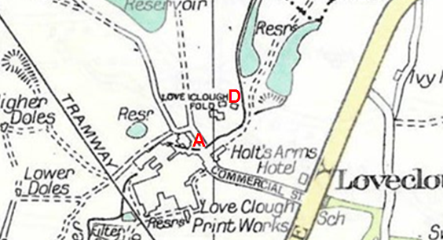
Observations |  | The route under investigation (and the route of Footpath 9 Rawtenstall) are not shown on the map.
Investigating Officer's Comments |  | If the route under investigation existed at the time that the map was compiled it was not considered to be a sufficiently important or vehicular highway to be included on a map of this kind.
6 Inch OS Map | 1955 | The OS base map for the Definitive Map, First Review, was published in 1955 at a scale of 6 inches to 1 mile (1:10,560). This map was revised before 1930 and is probably based on the same survey as the 1930s 25-inch map.
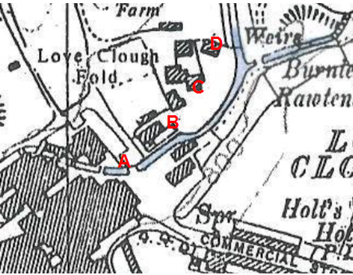
Observations |  | This 6 inch map has been enlarged and the watercourse coloured blue by officers so that the detail can be seen easily within the report.  A solid line is shown across the route just east of point A and beyond that the route would have passed along the enclosed section to point B. The route is not shown between point B-C-D although no feature is shown which might have prevented access. A line is shown across the route just north of point D.  An alternative access is shown to Love Clough Fold further north of the route under investigation.
Investigating Officer's Comments |  | The route under investigation is not shown although it may have been available on the ground. Access may have been restricted close to point A and immediately beyond point D.
1:2500 OS Map | 1962 | Further edition of 25 inch map reconstituted from former county series and revised in 1960 and published 1962 as national grid series.
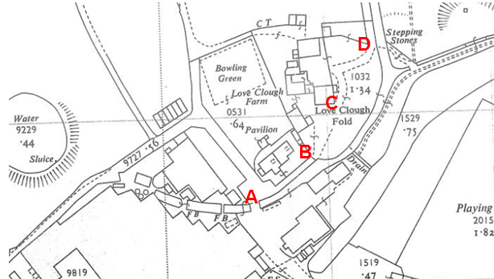
Observations |  | The map shows access onto the route at point A being open and the route is shown along an enclosed strip between point A and point B. A line is shown across the route at point B and a track is indicated (double pecked lines) along same line as the route under investigation to point C. This track continues to point D via access to a property between point C and point D but was unenclosed suggesting the route C-D may have been available.  Access onto Footpath 9 appears to be available from point D and the words stepping stones are shown adjacent to point D.
Investigating Officer's Comments |  | Access onto the route under investigation appears to be available at point A and the route accessible to point B. A gate is probably in existence at point A but it is not possible to determine from the Ordnance Survey mapping. A visible track existed through Love Clough Fold to point D which deviates slightly from the route under investigation but indicates that access was available through the property and not just to it. The track is unbounded (as indicated by pecked lines) so it was likely that anyone walking from point B to point D could have taken a direct route.  An extract of this map was also submitted by the Residents Association who have objected to the application. They consider that the map does not show the application route and that the 'beaten track' provided vehicular access to the farm and outbuildings. The Investigating Officer would agree that the track shown through Love Clough Fold would more than likely have provided vehicular access to the farm and buildings. However, its physical existence as a route through the farmyard also supports and is consistent with the user evidence that has been submitted in relation to this application.
Aerial photograph | 1960s | The black and white aerial photograph taken in the 1960s and available to view on GIS.
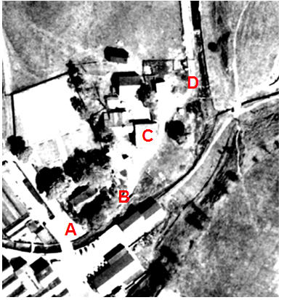
Observations |  | Although it appears to be, it is not possible to be certain whether access was available between point A and point B due to tree cover. A clearly defined track can be seen extending from point B on the photograph to point C and on to point D.
Investigating Officer's Comments |  | The aerial photograph supports the user evidence that has been submitted that the route under investigation existed on the ground and shows that it appeared to be capable of being used in the 1960s.
Aerial Photograph | 2000 | Aerial photograph available to view on GIS.
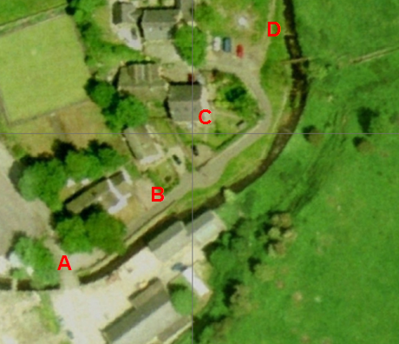
Observations |  | By 2000 it can be seen that there have been changes to the area crossed by the route under investigation. Access between point A and point B can be seen to exist along a hard-surfaced road which then extends in a north easterly direction before curving round to intersect the route under investigation between point C and point D. The route under investigation does not appear to be accessible between point B and point C and from point C to the interception of the new 'road' midway between point C and point D but from this point to point D the route under investigation can be seen.
Investigating Officer's Comments |  | Redevelopment of the farm has resulted in the construction of an access road and the fencing off of land to provide garden areas. It may still have been possible to walk the route under investigation between point A and point B but use of the full length of the route under investigation on its exact alignment was no longer possible.
Aerial Photograph | 2010 | Aerial photograph available to view on GIS.
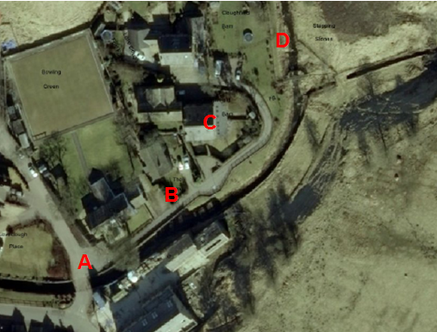
Observations |  | Further development of the site has taken place. The route under investigation still exists between point A and point B but access along the route between point B and point D is obstructed by numerous fences and garden areas.
Investigating Officer's Comments |  | The route under investigation may have been useable between point A and point B but not between B and D.
Definitive Map Records |  | The National Parks and Access to the Countryside Act 1949 required the County Council to prepare a Definitive Map and Statement of Public Rights of Way.  Records were searched in the Lancashire Records Office to find any correspondence concerning the preparation of the Definitive Map in the early 1950s.
Parish Survey Map | 1950-1952 | The initial survey of public rights of way was carried out by the parish council rural district l areas and the maps and schedules were submitted to the County Council. In the case of urban districts and municipal boroughs the map and schedule produced was used, without alteration, as the Draft Map and Statement.
Observations |  | Rawtenstall was a municipal borough in the early 1950s and so a parish survey map was not compiled.
Draft Map |  | The Draft Maps were given a “relevant date” (1st January 1953) and notice was published that the draft map for Lancashire had been prepared. The draft map was placed on deposit for a minimum period of 4 months on 1st January 1955 for the public, including landowners, to inspect them and report any omissions or other mistakes. Hearings were held into these objections, and recommendations made to accept or reject them on the evidence presented.
Observations |  | The route under investigation was not shown on the Draft Map of Public Rights of Way for Rawtenstall and there no representations made to the County Council in relation to it.
Provisional Map |  | Once all representations relating to the publication of the draft map were resolved, the amended Draft Map became the Provisional Map which was published in 1960, and was available for 28 days for inspection. At this stage, only landowners, lessees and tenants could apply for amendments to the map, but the public could not. Objections by this stage had to be made to the Crown Court.
Observations |  | The route under investigation was not shown on the Provisional Map and there were no representations made to the County Council in relation to it.
The First Definitive Map and Statement |  | The Provisional Map, as amended, was published as the Definitive Map in 1962.
Observations |  | The route under investigation was not shown on the First Definitive Map and Statement.
Revised Definitive Map of Public Rights of Way (First Review) |  | Legislation required that the Definitive Map be reviewed, and legal changes such as diversion orders, extinguishment orders and creation orders be incorporated into a Definitive Map First Review. On 25th April 1975 (except in small areas of the County) the Revised Definitive Map of Public Rights of Way (First Review) was published with a relevant date of 1st September 1966. No further reviews of the Definitive Map have been carried out. However, since the coming into operation of the Wildlife and Countryside Act 1981, the Definitive Map has been subject to a continuous review process.
Observations |  | The route under investigation is not shown on the Revised Definitive Map of Public Rights of Way (First Review).
Investigating Officer's Comments |  | From 1953 through to 1975 there is no indication that the route under investigation was considered to be a public right of way by the Surveying Authority. There were no objections to the fact that the route was not shown from the public when the maps were placed on deposit for inspection at any stage of the preparation of the Definitive Map.
Photographs provided by Mr David Collinge | Undated but prior to redevelopment of farm | Mr Collinge completed a user evidence form that was submitted with the 2005 application and when interviewed by Legal Services provided the photographs subsequently used to confirm the route that people claim to have used.
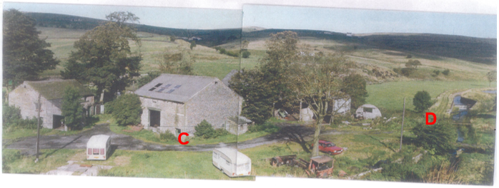
Observations |  | The photograph clearly shows the building that was subsequently converted into the two dwellings that make up Cloughfold Barn (adjacent to point C) and the property known as 'The Barn' with a track passing the buildings that corresponds to the route under investigation and which shows the continuation onto Footpath 9 and the crossing of the watercourse adjacent to point D. The shape of the track and footprint of the buildings is consistent with the 1:2500 map reconstituted from former county series and revised in 1960 and published 1962.
Investigating Officer's Comments |  | The route under investigation physically existed leading from point B through point C and on to point D when the photograph was taken and appeared to be capable of use.
Undated photograph |  | Undated photograph submitted with 2005 application.
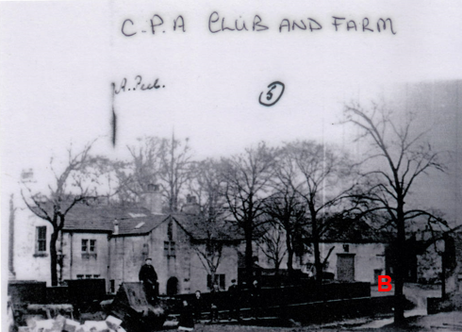
Observations |  | This undated photograph shows the building that is now known as the CPA Social and Bowling Club and the walled route between point A and point B providing access to the farm as being open and available.
Investigating Officer's Comments |  | The photograph confirms that the route between point A and point B existed as a walled route and that access appeared to be available to the farm yard.
Aerial Photograph submitted by Loveclough Fold Residents Association | C1960 | Aerial photograph submitted by Loveclough Fold Residents Association.
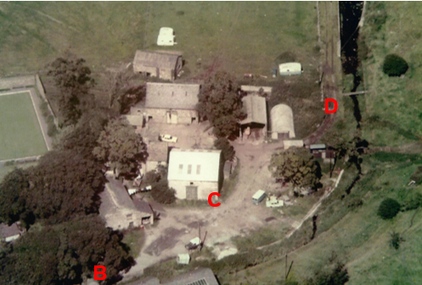
Observations |  | The aerial photograph is undated but is thought by the Residents Association to have been taken in the early 1960s. It provides a clear view of the farm yard through which the application route runs between point B and point D.  The photograph clearly shows the building that was subsequently converted into the two dwellings that make up 'Clough Fold Barn' (adjacent to point C) and the property known as 'The Barn'.  A wide track consistent with vehicular access to and around the various farm building can be clearly seen and the full length of the route under investigation between point B and point D looks to have been accessible through to point D.  The shape of the track and footprint of the buildings is consistent with the 1:2500 map reconstituted from former county series and revised in 1960 and published 1962.
Investigating Officer's Comments |  | The route under investigation physically existed leading from point B through point C and on to point D when the photograph was taken and appeared to be capable of use. The fact that the route passed through a farm along an access route also used by vehicles is not inconsistent with public rights of access on foot.
Photographs submitted by Mr Ashworth | 1989 | When consulted about the original application in 2005 the owner of Loveclough Fold Farm wrote a letter objecting to the application and enclosed a number of photographs, three of which are included below.  Mr Ashworth said that he purchased Loveclough Fold Farm in 1989.  Photograph 1 has the date September 1989 handwritten on the back of it. Mr Ashworth states that it shows the 'access road past barns owned by Mr and Mrs Smith and Mr and Mrs Felinish' and states that the 'access road' goes round to the farm yard and dairy.  Photograph 2 also has the date September 1989 written on the back of it. It is said by Mr Ashworth to show the 'access road' past the front of the barn owned by Mr and Mrs Felinish and round into the farm yard/dairy.  Photograph 3 is undated but is described by Mr Ashworth as showing the 'access road' as it 'was'. He describes the access road as running close to the gable end of the barn and round the back of the farm to the dairy, barn and muck midden.
Photograph 1
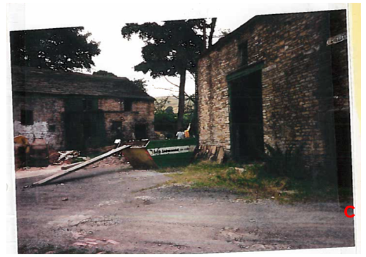
Photograph 2
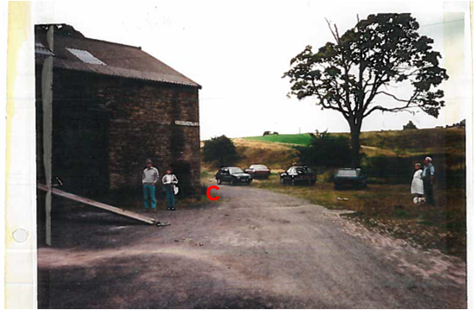
Photograph 3
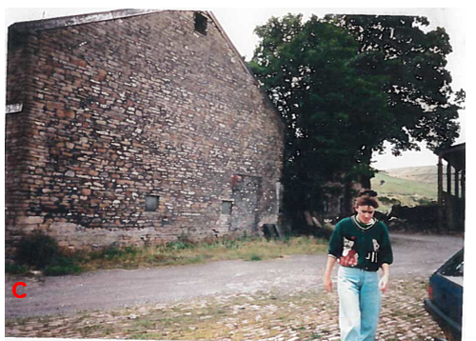
Observations |  | The photographs provide further evidence of the layout of the farm and associated buildings prior to redevelopment. They show the access route passing through point C which appeared to consist of a mixture of compacted stone/earth.
Investigating Officer's Comments |  | The photographs are consistent with earlier aerial photographs and Ordnance Survey plans that show the farm prior to redevelopment. The route through point C appears to be open and available to use and the fact that the route passed through a farm along an access route also used by vehicles is not inconsistent with public rights of access on foot.
Statutory deposit and declaration made under section 31(6) Highways Act 1980 |  | The owner of land may at any time deposit with the County Council a map and statement indicating what (if any) ways over the land he admits to having been dedicated as highways. A statutory declaration may then be made by that landowner or by his successors in title within ten years from the date of the deposit (or within ten years from the date on which any previous declaration was last lodged) affording protection to a landowner against a claim being made for a public right of way on the basis of future use (always provided that there is no other evidence of an intention to dedicate a public right of way).  Depositing a map, statement and declaration does not take away any rights which have already been established through past use. However, depositing the documents will immediately fix a point at which any unacknowledged rights are brought into question. The onus will then be on anyone claiming that a right of way exists to demonstrate that it has already been established. Under deemed statutory dedication the 20 year period would thus be counted back from the date of the declaration (or from any earlier act that effectively brought the status of the route into question).
Observations |  | No Highways Act 1980 Section 31(6) deposits have been lodged with the County council for the area over which the route under investigation runs.
Investigating Officer's Comments |  | There is no indication by the landowners under this provision of non-intention to dedicate public rights of way over this land.

The affected land is not designated as access land under the Countryside and Rights of Way Act 2000 and is not registered common land.

Landownership

Point A shown on the committee plan is owned by Avonbraid Limited, Molteno House, 302 Regents Park Road, London N3 2JX. Part of the route between A and B is unregistered. Part of the route near Point B and Point D is owned by David Haworth Ashworth and Alison Jane Ashworth, Loveclough Fold Farm, Loveclough, Rossendale, Lancs BB4 8QT. David Stuart Hempsall and Diane Ewart-Jones, The Barn, Loveclough Fold, Rossendale, Lancashire BB4 8QT are also affected by this route. Point C is owned by Stephen Felinski and Sally Ann Felinski, 1 Clough Fold Barn, Loveclough Fold, Rossendale, Lancs BB4 8QT, and the land just after Point C is owned by James Richard Tozer and Dawn Kimberley Tozer, 2 Clough Fold Barn, Loveclough Fold, Loveclough, Rossendale, Lancashire BB4 8QT.

Summary

The early maps do not show the route with the exception of A-B which was defined by boundaries shown on County Series Ordnance Survey maps. The route under investigation would have linked to the stepping stones.

The 1930 25 inch Ordnance Survey map does not show the route under investigation– other than the enclosed section between point A and B but access along the route may have been possible through the farm as reinforced by the 1940s aerial photograph which shows a faint line consistent with pedestrian use between point B-C-D.

The most relevant pieces of map and photographic evidence examined are the 1:2500 OS map published in 1962, the 1960s aerial photograph, undated photographs taken by David Collinge believed to be dated from the 1960s and the aerial photograph submitted by the Loveclough Fold Residents Association (c1960) all of which clearly show that a physically defined route consistent with that of the route under investigation existed through the farm prior to redevelopment and that it appeared to be capable of being used.

Legal and Democratic Service's Observations

16 users of the 2006 Order route were interviewed and it came to light that the evidence they provided relates up until 1989/1990 to the route shown on the attached committee plan A-B-C-D, their evidence is set out below (these user forms were completed in 2004).The use after 1989/1990 was of the new access track at the development

All 16 users have used the old track through the farm on foot. The years from which they used the route varies:
1930 (1) 1933 (1) 1939 (1) 1956(1) 1947 (1)
1950 (1) 1954(1) 1958(1) 1961(2) 1967(1)
1969 (1) 1972 (1) 1974 (1) 1980 (1)
1 user did not specify.

The main places the users where going included the Printworks, the CPA Club, walking to other Public Rights of Way, fishing lodges, Crawshawbooth, Whinny Hill, Commercial Street, riverside, Clowbridge and other surrounding countryside.
The main purposes for using the route included walking the dog, for pleasure / leisure, fishing, picnics and walking to work. The use of the route per year varies from 2-5 times, 20-35 times, once per week, 150 per year, 3-4 times per week, almost every day and constantly.

None of the users have ever used the route on horseback, however 2 users have used the route on a motorcycle / vehicle between the years of 1972-1986 and 1992-1999.

Most users agree that the route has always run over the same line however one user mentions there was a slight variation from near the buildings to the new road in 1986 (as he recalled). Another user states 'no' to this question but didn’t provide any further details.

9 users agree that there are no stiles / gates / fences along the route, 1 user mentions where the two tall black gates are at the moment there used to be a farm gate, another user mention having trouble getting over the stile just over the bridge, 2 users state new gates were erected in 2004 and one of the user mentions the gates are closed but unlocked and one other user mentions there are gates adjacent to the CPA Club. However none of the users mentions any of the gates / stiles being locked or preventing any access.

2 of the users worked for a landowner, one worked on Rileys Farm from 1972-1991 but never received any instructions and the other worked for a local farmer (J Bridge) between the years of 1969-1977 and also never received any instructions.

Since the dwellings have been built one user has been told they had no right to use the path, one user has received unkind looks but has not been confronted or ever turned back, and another user has been stopped but carried on along the route. 6 of the users however have heard of others being stopped or turned back, some of these mention that others no longer use the route.

8 of the users have never been told that the route they were using is not a public right of way, however other users provided the following information, 1 user was told about 5 years before 2004 that the route was not a public right of way and was a private way, another user has been told it is private and has not used the route since, another user was challenged by children and told that they couldn’t go through the gate as it was private, and 1 user mentions the members of Loveclough Angling had been stopped and told that the land was private and that they had no right to use the path.

2 users mention seeing notices along the route that state 'private', and none of the users have ever asked permission to use the route.

Further information has been provided by users since the interviews were carried out, this information is set out below.

- 1 user mainly used the route for work (Printworks) however Printworks shut down in 1980 but continued to use the route to walk the dog.
- Developers started work on the land in early 1990, even though work was ongoing users could still use the route
- 1 user used this route for family walks growing up and then continued to use the route when he joined the fishing club
- A user was told 'probably 1999' when people moved in that the path was private, but then let the user walk through
- A user mentions that when the developments took place they put the gardens where the track used to run
- Another user has used it since 1961 for getting to work, or going to the club and lodge for past time activities, when the owners sold to the developers a new track was put in and fenced
- 1 user mentions that when using the route to get to the club or during the summer time when walking the dog he would meet lots of people along the way other dog walkers and children playing
- Before 2004 1 user states that nobody said anything to him when he used the path and he often took his kids down to play
- A few of the users mentioned the previous owners never bothered about people using the route and they were only challenged / prevented when the new owners arrived

After carrying out the interviews officers wrote to the other users who did not attend an interview with a copy of the photograph provided by Mr Collinge to ask them to draw on the exact route they used before the development was carried out, 58 users replied and marked on the route along the old track. It is considered that their pre 1989 use is use of the old farm track and therefore the user evidence in this matter is significant.

Information from the Landowners

Recent consultations have been carried out with the landowners regarding the route shown on the attached Committee plan, their information is detailed below.

The landowners affected by the route have formed Loveclough Fold Residents Association and the Chairman Mr David Hempsall has provided a response on their behalf, the initial points raised in the first letter are as follows:
- Lancashire County Council's consultation letter was identical to the consultation letter submitted for the previous claimed route in 2005, a copy of this letter was attached.
- He states that residents complied with the terms of that letter and the matter was then concluded in favour of the residents.
- The only other query relating to Loveclough Fold was raised in 1997 after the previous landowners had failed to comply with an Enforcement Order; at Rossendale Borough Council’s Development Control Sub-Committee meeting on 7 May 1997, retrospective planning permission was given (a copy of this was provided) and the relevant Enforcement Order was withdrawn (copy provided).
- Your letter does not explain why an issue which was settled almost a decade ago is now being exhumed. (Lancashire County Council have since replied to Mr Hempsall to explain the procedure)
- The resurrection of a matter long since settled strikes residents as being frivolous, vexatious and calculated to cause anxiety and stress.
Mr Hempsall then submitted further evidence to support his objection. He provided a copy of a 1960's aerial photograph and a copy of the Ordnance Survey map of 1960. And states 'the aerial photograph of what in the 1960s was a farm and its outbuildings: the vehicles shown allow pretty precise dating. With respect, I venture to suggest that this is superior to the bodged up panorama which you sent on a previous occasion. I am bound to point out that the present dwellings consist of either (1) the buildings shown or (2) more recent structures erected on the footprint of those farm buildings.'

He then goes on to say 'the second attachment is a copy of the Ordnance Survey map of 1960 which clearly shows the scene depicted in the aerial photograph. From both the attachments, it will be clear that (a) there was no path - and certainly none going towards the footbridge which simply did not exist then - and (b) the beaten track shown both in the photograph and on the map gave vehicular access to the farm and its outbuildings. Neither attachment shows any trace at all of the claimed path.
Indeed, it is the residents' contention that this evidence points to the existence of only one definitive path: that on the south east bank of the Limey Water which is a matter which, with the assistance of an independent expert, the residents are pursuing as a wholly separate matter.'

Avonbraid Limited who own the land around Point A on the committee plan provided a plan that outlines their ownership but didn’t actually provide any comments regarding the claimed public footpath.

An objection to the consultation of the Order that was made in 2006 by the residents of the properties affected by the route provides the information below about a route before the development.

The residents say that there was never an issue regarding a footpath existing along the access area to the six converted barns and old farmhouse. The search completed by solicitors showed that there was no footpath or right of way along the access route, but that a footpath existed on the other side of the river (Public Footpath No.4) connecting to Public Footpath No.10 and also Public Footpath No.9 which crossed stepping stones and then ran inside the garden (along the river bank) and then on through adjacent farmland.

They say that the footpath in question served a group of small terraced houses which existed on the east bank of the river and were later demolished in the 1950/60s. These houses served as accommodation for workers of Love Clough Dye Works who owned the whole site until the 1980s.

The residents explained that the farm was sold to Riley Brothers, who owned and farmed the land adjacent to the dye works. They later sold the land to a developer, K and S Ainsworth, who sold the properties in a derelict state to the current occupiers and others over a period of 3 to 4 years.

Riley Bros. submit that Tootal Print Works initially owned the land at Love Clough Fold, along with the dwellings; J and G Bridge rented the farm. In 1983 Rileys purchased the land from Tootal and Mr J Bridge continued to live in the farmhouse and rent a small plot of land until his retirement. In 1988 following Mr Bridge’s retirement Rileys decided to sell the farmhouse and surrounding barns for development. In March 1989 these were sold to K and S Ainsworth and Rileys retained the surrounding land for farming purposes. At no time have Rileys ever given permission for people to use the path in front of the properties as a footpath although they don’t deny that some locals may have used it to visit the farm to collect milk over the years. However, whilst they owned the land, permission has never been sought either verbally or written, nor would it have been granted.

To summarise, the residents of the Love Clough Fold state:-

1. All walks that can be made by using the proposed footpath can be made using the footpath on the opposite side of Limy Water. There is no need to introduce a new, parallel path.

2. Use of the path prior to 1987 was to, not through, the farm. The existing Public Footpath No.4 divided near the present bridge and a short length crossed the river by stepping stones to the farm. This can be verified by the Riley family, previous owners of the land in question and owners of all adjacent fields.

Assessment of the Evidence

The Law - See Annex 'A'

In Support of Making an Order

User evidence
Aerial photographs showing available route
OS map evidence
Photographs
Connection to footpath network and stepping stones
No evidence of action by landowner prior to 1989

Against Making an Order

Location being working farm
Possible access to the farm
Another footpath nearby

Conclusion

This matter is unusual in that it stems from the realisation , following interviewing witnesses, that the line of the more modern access route claimed in 2004 was not on the same line as the pre 1989 route used by members of the public. Instead the route followed an old track through the farm which was there until approximately 21990 when the development of the farm into residences began. The route through the farm has been investigated further and the evidence is detailed in the report.

There is no express dedication and so Committee is asked to consider whether there is sufficient evidence from which to deem dedication under S31 or infer dedication from all the circumstances at common law.

Considering S31 it is considered that there were some challenges to some users of the route as early as 1989 but the main challenge would be a at that time when the development of the site affected the old route which became incorporated into new garden areas. It is suggested that the twenty years of use to be considered would be 1969-1989 or 1970-1990

Looking at the user evidence from both those interviewed and those who provided user form and confirmation of their route, it is suggested that the local users used the track through the farm then tried to continue on the line of the new access track at the development and this is why their use refers to use upto 2004.

Looking back to an earlier period of use it is suggested that there is sufficient evidence of use by the public without interruption and with no evidence of actions taken by the landowner for the twenty years being considered such that dedication can be deemed under S31. Committee are asked to discount evidence from the user who worked at the farm as this use would probably not be as of right.

Considering also the use of the route and lack of action by the owner as circumstances from which the owners intention to dedicate a footpath for the public could be inferred, it is suggested that this evidence too would be sufficient from which to draw such an inference of a dedication in the years before the new development post 1989.

Taking all the evidence into account , on balance, Committee may consider that there be sufficient evidence to make an Order in this matter to record a footpath on route A-D and promote same to confirmation.

As the earlier 2006 Order has objections it must be submitted to the Secretary of State but as the evidence of a footpath on the 2006 Order line is now difficult to sustain and there is the additional issue of incorrect notation, Committee may feel it is appropriate to withdraw support from that Order and submit it to the Secretary of State requesting non- confirmation.

Alternative options to be considered - N/A

Local Government (Access to Information) Act 1985

List of Background Papers

Paper | Date | Contact/Directorate/Tel
All documents on File Ref: 804-518 |  | Megan Brindle , 01772 535604, Legal and Democratic Services
Reason for inclusion in Part II, if appropriate

N/A

The Ordnance Survey (OS) has produced topographic maps at different scales (historically one inch to one mile, six inches to one mile and 1:2500 scale which is approximately 25 inches to one mile). Ordnance Survey mapping began in Lancashire in the late 1830s with the 6-inch maps being published in the 1840s. The large scale 25-inch maps which were first published in the 1890s provide good evidence of the position of routes at the time of survey and of the position of buildings and other structures. They generally do not provide evidence of the legal status of routes, and carry a disclaimer that the depiction of a path or track is no evidence of the existence of a public right of way.
Aerial photographs can show the existence of paths and tracks, especially across open areas, and changes to buildings and field boundaries for example. Sometimes it is not possible to enlarge the photos and retain their clarity, and there can also be problems with trees and shadows obscuring relevant features.

